

Embedded Systems and Internet of Things

Mini Project Report

On

Advanced Driver Fatigue Detection System

By

Kartik Maski(08)

Araham Sayeed(22)

Ansh Tandale(19)

Brandon Cerejo(16)

Under the guidance of

*Prof. Shiv Sutar*

Department of Computer Engineering and Technology

School of Computer Science and Engineering

Dr. Vishwanath Karad MIT World Peace University

AY 2023-24 Semester IV

***Problem statement: -***

**Driver drowsiness Alert and Alarm System**

***Introduction: -***

Drowsy driving is a serious safety concern, leading to thousands of accidents and fatalities each year. To address this issue, technological solutions like the Sleeping Driver Alert and Alarming System are being developed. This system utilizes advanced algorithms and sensors to detect signs of drowsiness in drivers, such as eye closure and head nodding. Upon detection, the system activates alarms, alerts, or even physical interventions to wake the driver and prevent potential accidents. By providing timely warnings and interventions, this system aims to enhance road safety and reduce the risks associated with drowsy driving.

***Need Of the Project: -***

* **Motivation**

The motivation behind our project, the Sleeping Driver Alert and Alarming System, stems from the pressing need to address the issue of drowsy driving. Drowsy driving is a major cause of accidents worldwide, leading to injuries, fatalities, and economic losses. Traditional methods of combating drowsiness, such as roadside signs or periodic breaks, are often ineffective or impractical.

* **Existing Solutions**

Existing solutions, such as in-car alerts or lane departure warning systems, have limitations. They may not detect early signs of drowsiness or may rely on external factors like road conditions, which are not always reliable indicators of driver fatigue. Our project seeks to overcome these limitations by providing a comprehensive and proactive approach to detecting and alerting drivers to their drowsy state, thereby enhancing road safety and potentially saving lives.

***Objectives: -***

The objectives of our Sleeping Driver Alert and Alarming System project are as follows:

1. **Early Detection of Drowsiness:** Develop algorithms and use sensors to detect early signs of drowsiness in drivers, such as eye closure and head nodding.
2. **Real-time Monitoring:** Implement a system that can continuously monitor the driver's behavior and alertness levels.
3. **Accurate Alerting Mechanism:** Create an alerting mechanism that effectively notifies the driver when signs of drowsiness are detected, using auditory, visual, and/or physical alerts.
4. **User-Friendly Interface:** Design an intuitive user interface that allows for easy interaction and customization of alert settings.
5. **Data Logging and Analysis:** Incorporate a feature to log and analyze driving behavior data to provide insights into the frequency and severity of drowsy driving incidents.
6. **Integration with Existing Systems:** Ensure compatibility and integration with existing in-car systems and technologies for seamless adoption.
7. **Cost-Effective and Scalable:** Develop a solution that is cost-effective to implement and can be easily scaled for use in different vehicle types and environments.
8. **Safety and Reliability:** Prioritize safety and reliability in the design and implementation of the system to ensure its effectiveness in preventing accidents due to drowsy driving.

***Product Description: -***

**Driver Alert System for Safer Driving**

Our Driver Alert System is designed to keep drivers safe and prevent accidents caused by fatigue. Here's how it works:

**Features:**

1. **Real-Time Monitoring:** Our system uses smart sensors and technology to watch for signs of fatigue while you're driving. It keeps an eye on things like your blinking and head movements to see if you're getting tired.
2. **Predictive Alerts:** It can even predict when you might start feeling tired based on your past driving habits. This helps it give you a heads-up before you get too tired to keep driving safely.
3. **Customizable Alerts:** You can set up the system to give you warnings in a way that works best for you. Whether it's a sound or a vibration, you'll know when it's time to take a break.
4. **Helpful Feedback:** If the system notices you're getting sleepy, it will let you know right away. This helps you stay aware and take a break when you need it most.
5. **Easy Integration:** It's simple to connect our system with the tools you already use to manage your fleet. This means you can keep track of fatigue levels and make smart decisions to keep everyone safe.
6. **Works for Any Size Fleet:** Whether you have a big fleet or just a few vehicles, our system can help you keep your drivers safe and your operations running smoothly.

***List of Components: -***

Here is a list of components used in our Sleeping Driver Alert and Alarming System, along with descriptions of each sensor and actuator:

1. Camera: Used for capturing video of the driver's face to detect signs of drowsiness such as eye closure and head nodding. This helps in monitoring the driver's alertness level in real-time.
2. LEDs (Light-Emitting Diodes): Used as visual indicators to alert the driver when signs of drowsiness are detected. LEDs can be placed on the dashboard or near the driver's line of sight for better visibility.
3. Buzzer: Used as an auditory alert to notify the driver when signs of drowsiness are detected. The buzzer can emit a loud and distinct sound to grab the driver's attention.
4. Vibration Motor: Used as a physical alert to wake up the driver when signs of drowsiness are detected. The vibration motor can be embedded in the driver's seat or steering wheel to provide tactile feedback.
5. Microcontroller (e.g., Arduino or Raspberry Pi): Used to interface with and control all the components of the system. The microcontroller runs the drowsiness detection algorithm and activates the appropriate alerts based on the sensor inputs.
6. Power Supply: Provides the necessary power to all the components of the system. It can be a rechargeable battery or connected to the vehicle's power supply.

These components work together to create a comprehensive system that can effectively detect and alert drivers to prevent accidents due to drowsy driving.

**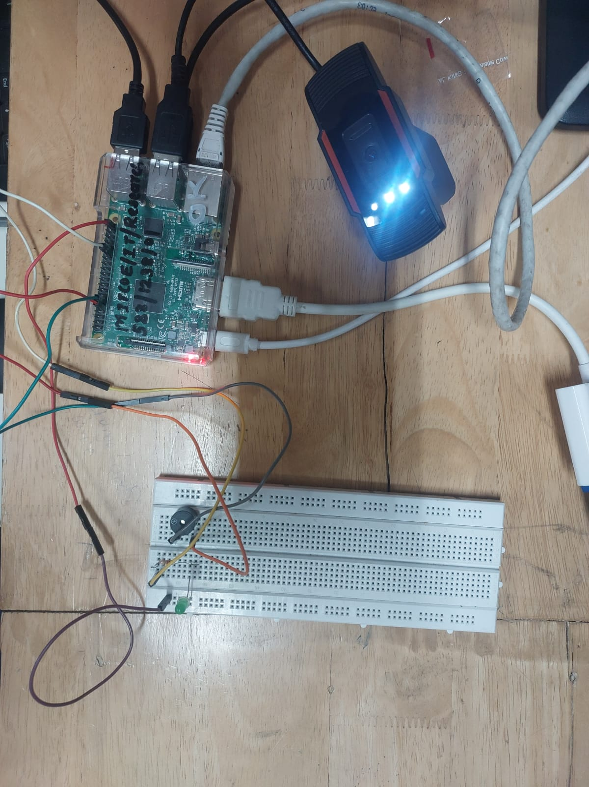*Circuit diagram: -***

**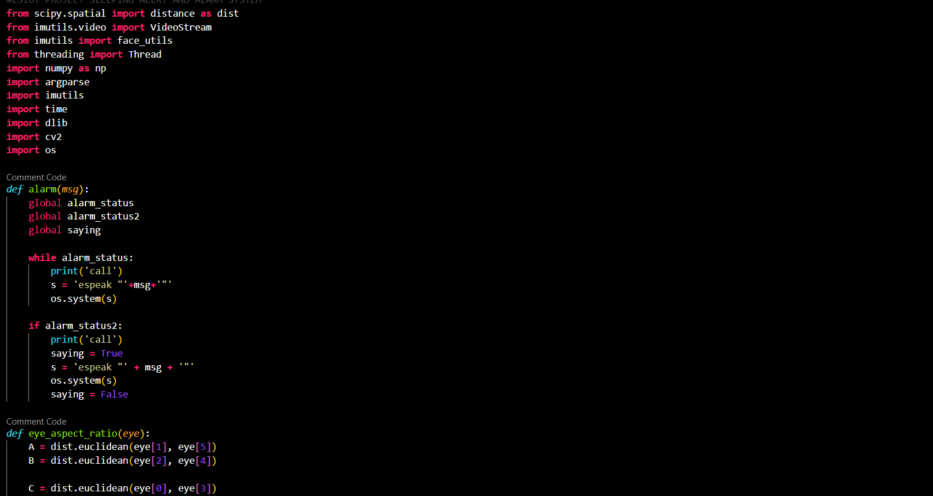*Code: -***

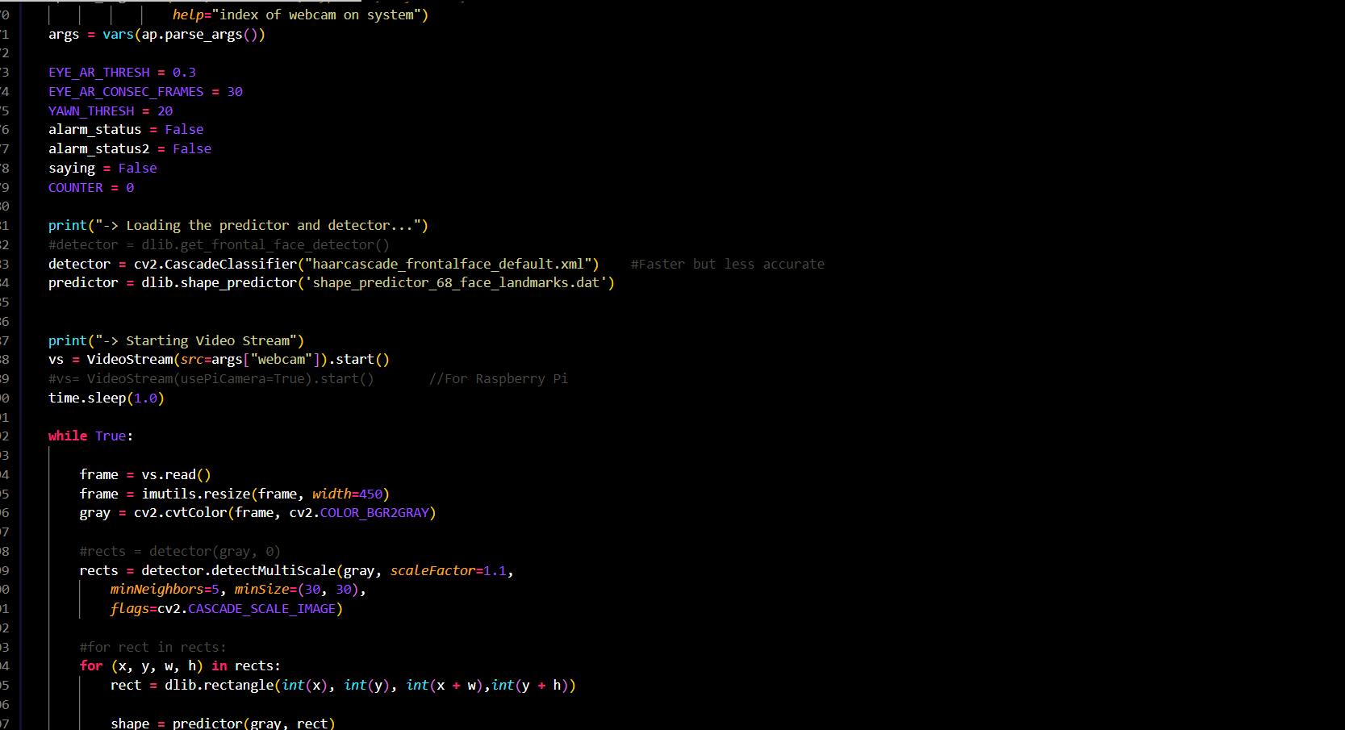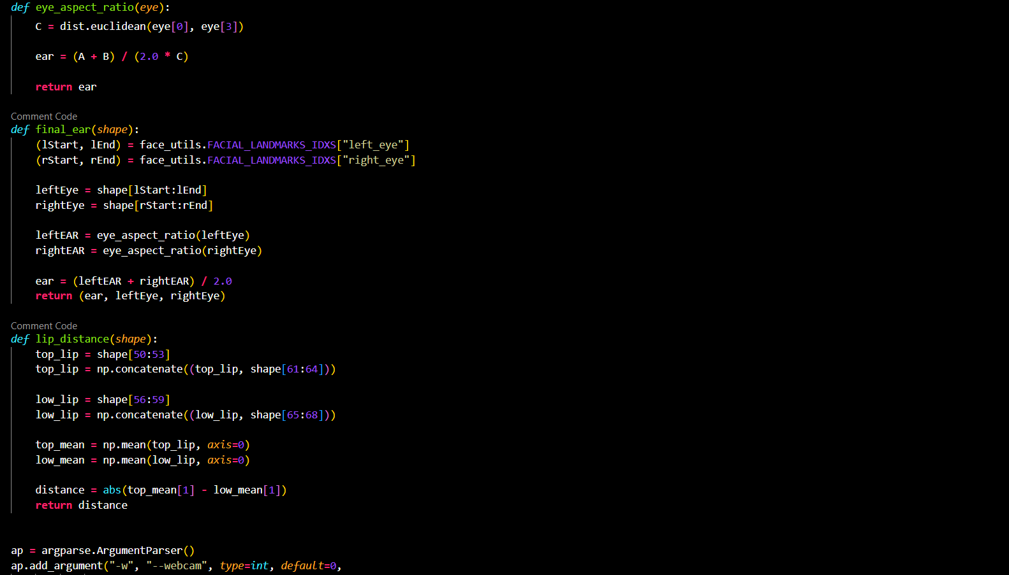

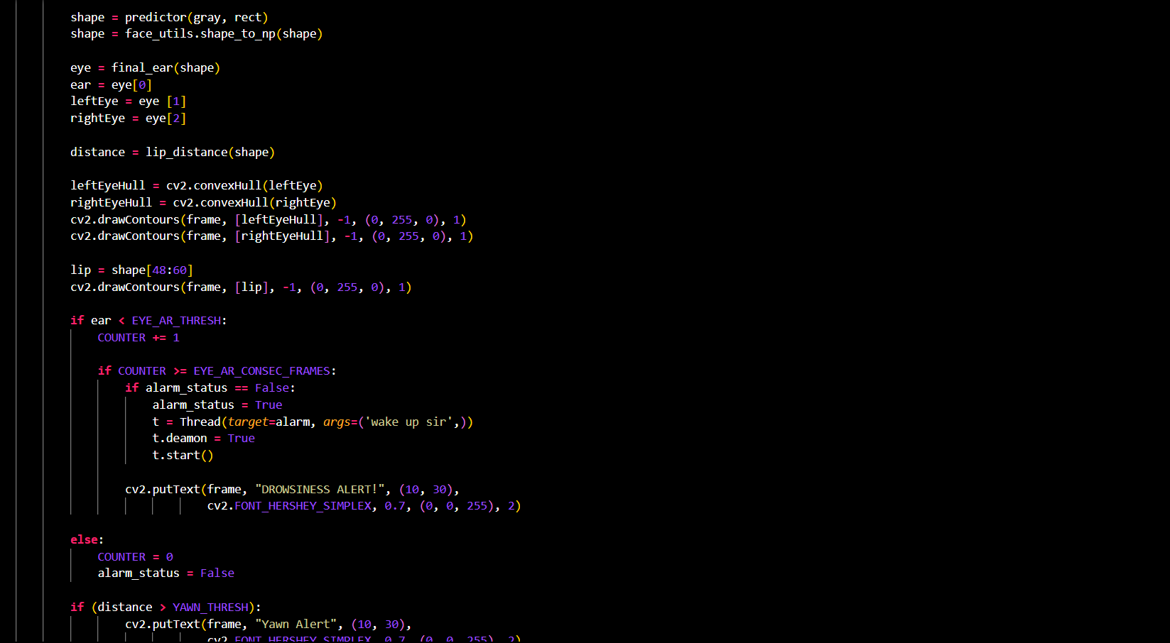

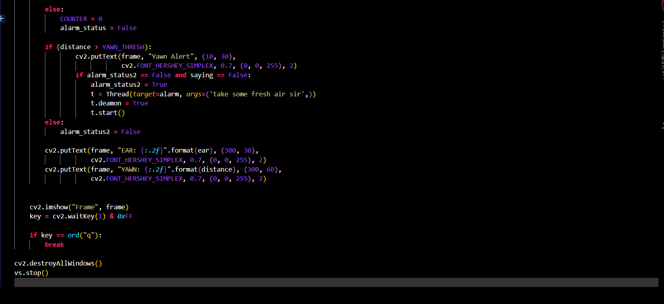

**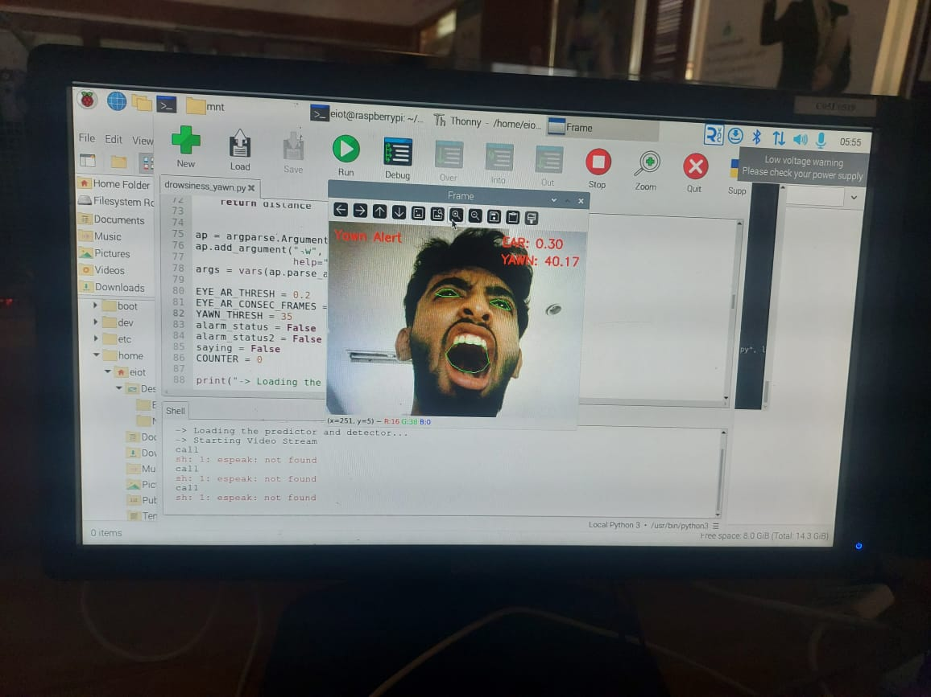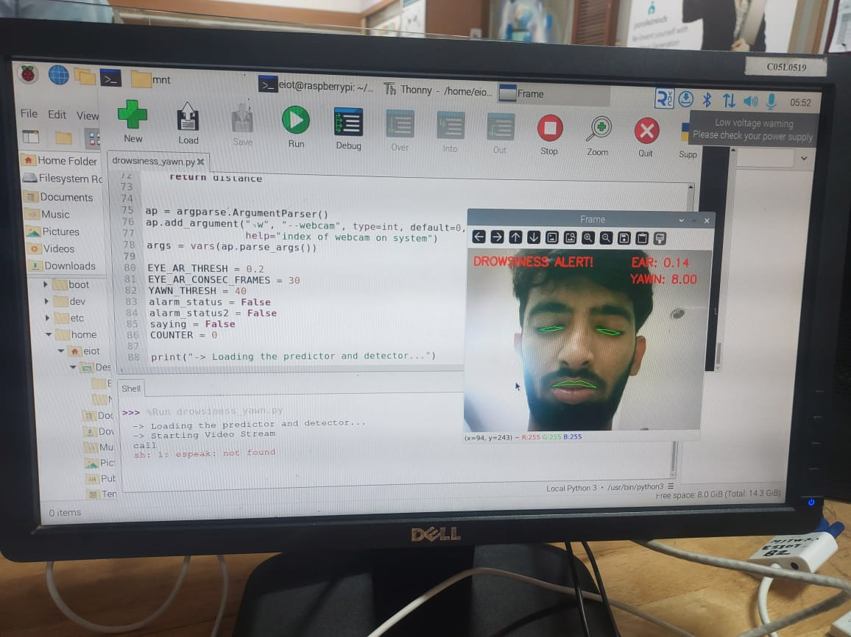*OUTPUT: -***

***Application: -***

The Sleeping Driver Alert and Alarming System has a wide range of applications, primarily aimed at enhancing road safety and preventing accidents caused by drowsy driving. Some of the key applications of the system include:

1. Automobiles: The system can be integrated into cars, trucks, and other vehicles to monitor the driver's alertness level and alert them when signs of drowsiness are detected.
2. Fleet Management: Fleet operators can use the system to monitor the alertness of their drivers in real-time and take corrective actions to prevent accidents and improve overall driver safety.
3. Public Transportation: The system can be installed in buses, trains, and other forms of public transportation to ensure that drivers or operators remain alert and focused on the road.
4. Commercial Vehicles: Companies operating commercial vehicles, such as delivery trucks or taxis, can use the system to ensure that their drivers are not driving drowsy, thus reducing the risk of accidents and liability.
5. Personal Vehicles: The system can also be used in personal vehicles to provide an added layer of safety for drivers and passengers, especially during long journeys or late-night drives.

Overall, the Sleeping Driver Alert and Alarming System has the potential to significantly reduce the number of accidents caused by drowsy driving and improve road safety for all road users.

***Conclusion: -***

In conclusion, the Sleeping Driver Alert and Alarming System is a crucial technological advancement aimed at combating the dangers of drowsy driving. By leveraging IoT technology and innovative sensor systems, our project seeks to provide a comprehensive solution to detect and alert drivers to signs of drowsiness in real-time.

***References: -*** IEEE Format

***CONTRIBUTION OF EACH TEAM MEMBER: -***

|  |  |
| --- | --- |
| **Araham Sayeed** | **Circuit Assembly** |
| **Ansh Tandale** | **Documentation and code Implementation** |
| **Brandon Cerejo** | **Code implementation and Circuit Assembly** |
| **Kartik Maski** | **Documentation and Circuit** |